**Logbook Entry Window**

# Geoff Anderson G3NPA, Jim Hargrave W5IFP and Aki Yoshida JA1NLX

## 1.0 BASIC SETUP

As the name implies, this is the window through which the main entries are made to the logbook. It is quite complex and highly configurable so you are well advised to take time to study this section to fully understand what facilities are available from here. The picture shown below is the most basic Logbook Entry Window.

The top line shows the Frequency, Mode and Band that will be logged. The Frequency will be derived from your radio if you have CAT control and it is set up and activated. If you do not have computer control, then the frequency can be set manually. The Mode and Band will be derived from your Bandplan or, if desired, they also can be set manually. Below the top line are edit boxes for Callsign, RST Sent, RST Received, Name and QTH. You MUST enter a callsign at the very least before you can transfer anything to the log.

To change between edit boxes use the <**TAB**> key on the keyboard. Conversely the <**Up Arrow**> key will act as a Back-Tab <**Shift+TAB**> key combination. To transfer the QSO information to the logbook, use the key combination <**Ctrl+L**>_or the <**Enter**> key.  If you wish to clear the whole entry window for any reason, use the <**F11**> key (if the focus is in the Logbook Entry window) (see the Helpfile topic The F11 Key Explained), the key combinations <**Ctr-C**>_or <**Alt+W**> or a left-click on the left side of the Logbook Entry window about 1/4 inch to the left of the entry fields. As a rule of thumb - click over Call, Sent, Rcvd, Name, Cmnt/QTH/Addr or bottom left user field caption.

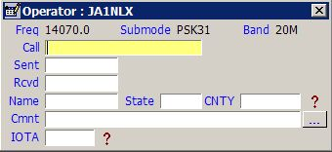

LBEW_1

As soon as you enter a callsign prefix that is recognized, the following will occur:

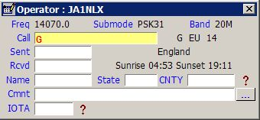

LBEW_2

**Note**: that the Country name, Sunrise and Sunset times, Short and Long Path beam headings and the Short Path distance are all calculated and displayed. If it should happen that you have many edit boxes visible, then some or all of this latter information may not be visible here. However, the same information is displayed on the Upper Status Bar at the bottom of the main window, so the information is still available.

Continuing with the Callsign entry, once you have typed sufficient information AND there are matching callsigns already in your log, Logger32 will display those callsigns (Callsign Preview). If the one you require is in the list presented, then selecting that callsign will place it in the Call edit box of the Logbook Entry window. If not, just continue to type in the remaining letters. See the example below:

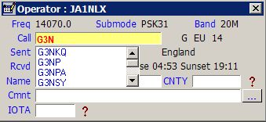

LBEW_3

If you do not see this type of presentation, then right-click in the Callsign edit box, select the" Setup" menu item from the pop-up menu and check "Show callsign preview" menu item from the menu list displayed.

Right-click in any edit box to show menu. Many examples are described later.

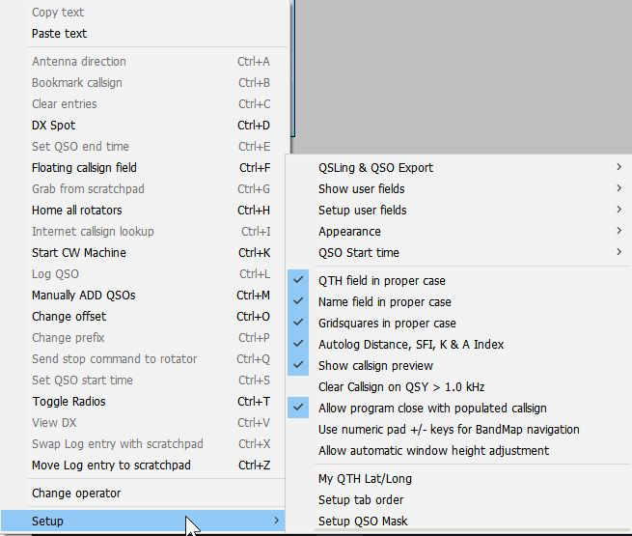

new LBEW_3A

**Note**: It is preferred that you enter a callsign in the format:  Callsign / Prefix modifier. For example W4xxx/1 (a W4 portable in area 1) or G3xxx/FR/T (A G prefix operating on Tromelin Island).

Logger32 will accept a number of different callsign formats BUT occasionally, especially where the prefix modifier is complex (like FR\T or KH0\M), the determined location, Zone etc., can be incorrect if other formats are used.

Logger32 has, in fact, seven more edit boxes that you can configure for use. To do this, right-click on any of the visible edit boxes to produce a pop-up menu. Select the Setup | Show user fields | Show all user fields menu items. This will activate all the user-definable edit boxes. If you only require one or a special combination of panes, then these may be selected using the Show User field # menu items.

**Note:** If the additional User FIelds have been configured, then the assigned Field Name will be displayed in the menu items in place of the Field #.

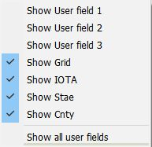

new LBEW_4

**Note**: Auto-logging of Distance does not require an internet connection. However, auto-logging of SFI, A_Index, and K_Index only occurs after at least one instance of a WWV or WCY report has been received via a connection to a DX Cluster node -- whether automatically originated by the node or from an SH/WWV or SH/WCY command sent to the cluster.

Logger32 will use the most recent SFI A and K numbers received until Logger32 has been closed -- even after the your connection to the Cluster drops or is deliberately disconnected.

With all edit boxes visible the Logbook Entry window will look like this:

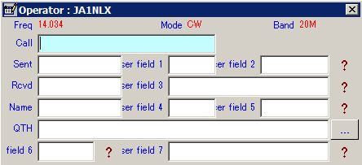

LBEW_7

Take note of the location of the seven user edit boxes and their numbering. Each one of these boxes can be set up to accept ANY ADIF type entry. Right-click on any of the edit boxes, select the "Setup | Setup user fields" menu items and pick the field of your choice. In the example below, USER 5 was selected.

Enter the label required, select the ADIF field type and in this case the <**Show Help**> button. Make other selections to suit. Be aware that the list of ADIF fields available from the pull-down list will change. Once one of the ADIF definitions has been used the same definition will NOT appear in the list again thus preventing its use in a second edit box. To restore the definition to the list you must remove it from the edit box that is using it.

For further information on the use of the "CW Machine Free field" option in the lower section of the setup window below, please see the CW Machine Window topic.

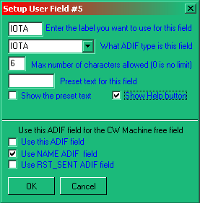

LBEW_8

The settings above for User 5 are shown below. The "?" mark is the Help button and a selecting this will reveal information about your IOTA contacts.

* + A LEFT-click will show information about the Island Group; and,  
      
    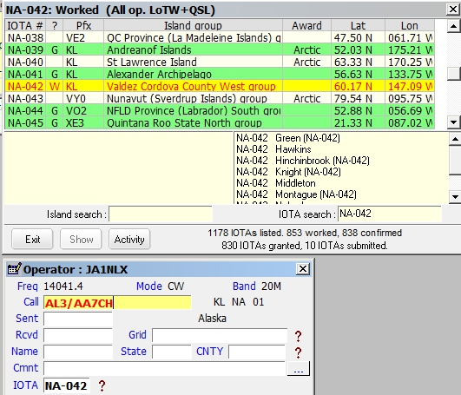  
      
    LBEW_8A
  + A RIGHT-click will open a generic window showing contacts with the IOTA Island.  
      
    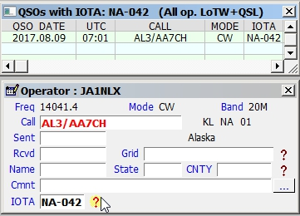  
      
    LBEW_8B

**Note**: The RIGHT-click feature also applies to the STATE and CNTY fields

**Note**: Only fields 2,3,5,6 and 7 can have a "?" Help button associated with them.

The settings for User 3 are shown below. The "?" mark is the Help button and a selecting this will reveal information about your Grid Square contacts.  You have an option to show Grid Square information for this year only. (2017 onlly in LBEW_8D).

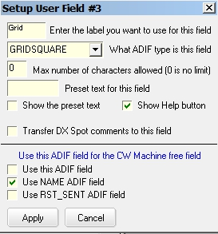

LBEW_8C

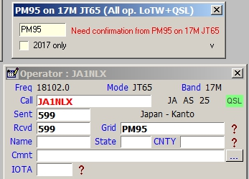

LBEW_8D

If you want to see this window as soon as you enter a Grid Square in Logbook Entry Window, then click "V" (LBEW_8D) and check "Show/hide this window....." option.

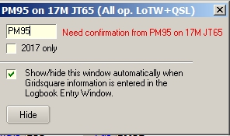

LBEW_8E

It is possible to edit boxes to display Upper Case only provided that the field definition is one of the USER # ADIF fields. The option to do this will ONLY appear if the ADIF field of USER 1,2 or 3 is being used.

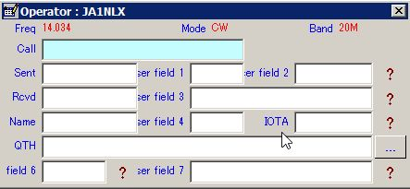

LBEW_9

If you wish to limit the number of characters that can be entered into a field or have something preset in a field, then complete the appropriate parts in the setup window for that field.

Shown below is an example for the Logbook Entry window.

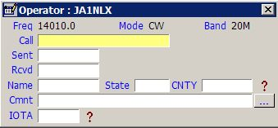

LBEW_10

**Note**: The button next to Cmnt field will cause the fields on this line to toggle between Comment, QTH and Address.

A new feature has been added whereby you can now add preset text to the Comment field. See the menu item "Setup user fields".

Selecting the "Setup Comments" menu item will display the Setup Comments field dialog box.

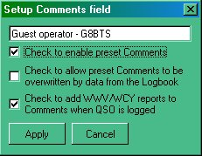

LBEW_12

Here you have the option to set a comment you may wish to add to the Comments column. Note that there are three selectable options:

* + If you want the phrase to appear, then you must check the "Check to enable" box;
  + If you would like to add the WWV/WCY reports received from a cluster, then check the bottom check box.

For example: with both of the above options selected, the Comments field in the log will fill as shown.

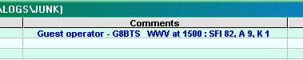

LBEW_13

* + If you want comments for a specific callsign already in the log to override the this comment, then click the middle check box. This assumes of course that you have selected to copy over the comments from the previous QSO using the QSO mask.

There is a potential for conflict with this option however. If the user has Comments checked in the QSO Mask, each successive QSO will append the WWV/WCY report for each QSO. The error message shown below will be generated if this conflict exists.

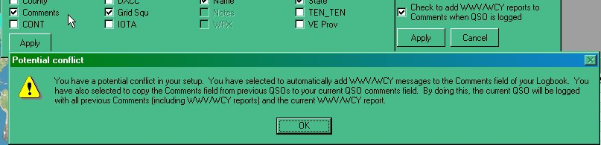

LBEW_14

In addition to that above, an automated feature has been introduced to record the A and K indices, the SFI and the distance to the QSO partner (in Km). Right-click on the Logbook Entry window and select the Setup | Autolog Distance SFI K and A Index menu items.

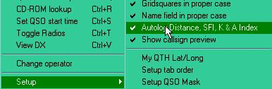

LBEW_15

With this option checked, QSOs are automatically logged with data from the WWV/WCY and Distance panels on the Lower Status bar.

**Notes**:

* + It is not necessary to have SFI, DISTANCE A and/or K_INDEX user fields on the Logbook Entry Window;
  + It is not necessary to have SFI, DISTANCE A and/or K_INDEX user fields visible on the Logbook Entry Window;
  + If the user has entered SFI, DISTANCE A and/or K_INDEX into user fields on the Logbook Entry Window, the field(s) will not be overwritten; and
  + If there is no data in the right side of the Lower Status bar from WWV or WCY, then nothing will be written to the SFI and/or A/K_INDEX fields.

### 2.0 QUICK QSY

Logger32 has the ability to accept an input frequency in the "Call" edit box of the Logbook Entry window. This input frequency must be in the format of the frequency recorded in the log. In the "Call" edit box, simply enter the frequency and press <**Enter**>. If you have a radio with a CAT interface, it will QSY to the frequency you have just entered.

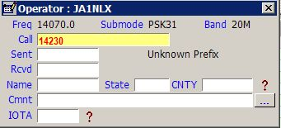

LBEW_16

In the example above, the <**TAB**> or <**Enter**> key has not been pressed. As soon as one of them is, the "Call" edit box will clear and the radio will go to the entered frequency.

The current Received frequency can also be changed by using the scroll wheel on the mouse. Place the cursor anywhere in the Logbook Entry window and rotate the scroll wheel. One direction will increase the frequency while a rotation in the other direction will decrease the frequency. The step size for each scroll wheel click can be selected from a menu item list by right-clicking on the actual frequency displayed alongside the word "Freq". Depending on the polling interval of your computer/transceiver interface, the speed of the frequency change may be somewhat slow. The change may not be immediate as if you were turning the radio's tuning knob.

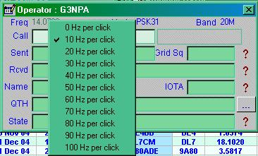

LBEW_17

## 3.0 OTHER SETUP MENU ITEMS

To access menu items right-click in any edit box and select Setup menu item.

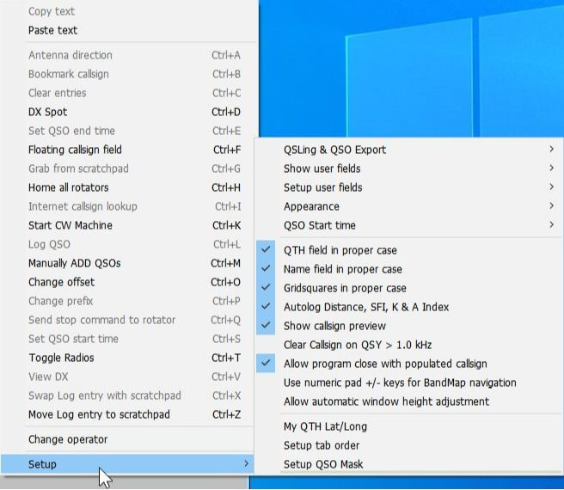

new LBEW_17A

**3.1 QSLing & QSO Export**

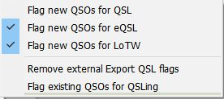

LBEW_17B

**Flag new QSOs for QSL, Flag new QSOs for eQSL and Flag new QSOs for LoTW:**

Check item for whick you want to flag automatically when QSO is logged.

Remove external Export QSL flags:

If you use external program which read eQSL Dump File.txt, Clublog Dump File.txt or ADIF audit trail.txt then you need to check “Export QSO for eQSL processing”, “Export QSO for Club Log Processing” or “Export QSO to ADIF trai”.

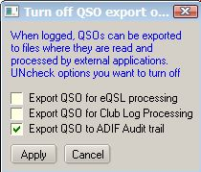

LBEW_17C

**Flag existing QSOs for QSLing:**

If you want to flag to be send for all QSOs then check each item. Click “Apply” This does nothing for QSO which is already flagged as QSL Sent.

If you want to remove all “QSL to send” flag then check “Remove all send QSL flags” and click “Apply”.

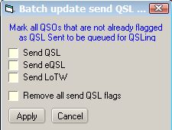

LBEW_17D

### 3.2 ~~3.1~~ Appearance

~~To access menu items right-click in any edit box and select Setup menu item.~~

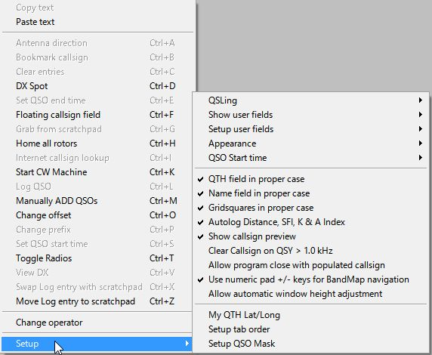

Remove this picture ~~LBEW_17A~~

The general appearance of the Logbook Entry window can be adjusted to suit individual tastes.You can change a whole range of items such as Background, Highlight and Font colors as required - for both the Data and the Field names.

### 3.3 ~~3.2~~ Entry Window Tab Order

Following the entry of a Callsign, you can arrange to <**Tab**> through the Logbook Entry window in any order you wish.

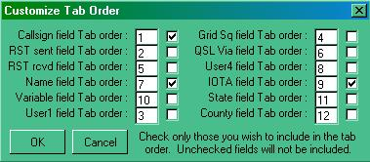

LBEW_18

In the left-hand edit box, enter the order number for each field to fall and if you require that field to be included in the tab sequence, place a check mark in the check box. In the example above only three fields have been selected in the order Callsign, Name and User 5 (which you have defined as the IOTA number). Having completed your selection, select the <OK> button.

Note that your bandplan can set the default RST sent (normally 599) and the RST received field will default to 599 if nothing is entered. In the above case, Having entered a callsign, a single <**Tab**> will take you to "Name" having filled in the two reports of 599 on its way.

### 3.4 ~~3.3~~ QSO Mask

Logger32 has the ability to look at your logbook and extract information from the last QSO you had with someone and display this in the Logbook Entry window. For example, if you had worked Bob K4CY previously and you had correctly recorded his name in the Name field, then the next time you enter his callsign, this information can be retrieved and put in the Logbook Entry window automatically. Select those items that you wish to be carried forward. In the example below, Name, QSL Via, QTH and State will all be transferred from the previous contact record to the new one. Now you know how Bob is so quick on coming back with your name if you work him twice!

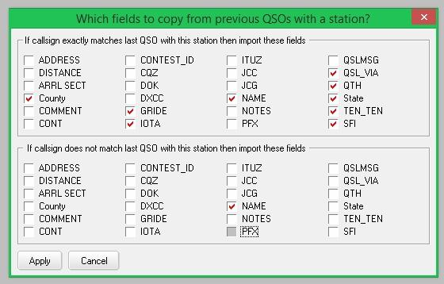

LBEW_19

### 3.5 ~~3.4~~ GridSquares in Proper Case

If this option is checked, then captured or directly input information will appear in the form "IO82nd".  If unchecked, the format will remain as typed (or captured).

### 3.6 ~~3.5~~ Name Field in Proper Case

If this option is checked, then captured or directly input, information will have the first letter of the name capitalized and the remainder in lower case, i.e., Geoff.  If unchecked, the format will remain as typed (or captured).

### 3.7 ~~3.6~~ QTH Field in Proper Case

If this option is checked, then captured or directly input information will have the initial letter of the name capitalized and the remainder in lower case, i.e., London. If umchecked, the format will remain as typed (or captured).

### 3.8 ~~3.7~~ QSO Start time

A QSO is transferred from the Logbook Entry window into the logbook following an <**Enter**> key or <**Ctrl+L**> key combination. This action also automatically sets the QSO end time. Two options to automatically set the Start Time are available:

### 3.7.1 When Callsign Field Loses Focus

If this option is selected, the QSO Start Time will be taken to be the moment you enter the <**TAB**> key to move away from the Call edit box to add further information into the Logbook Entry window. The <**Ctrl+S**> key combination will override the Start Time even if it is used before the first time the callsign field loses focus

### 3.7.2 When QSO Entered into Log

If this option is selected, then the Start Time will be the same as the End Time. Even with this option selected the <**Ctrl+S**> key combination will still record the Start Time if pressed.

**Note**: Both the Start and End times can be recorded automatically if the $starttime$ and $endtime$ MACROs are used in the shortcut key definitions in the MMTTY and MMVari windows. These macros are NOT available for use in the CW Machine.

## 3.9 ~~3.8~~ Clear Callsign On QSY

With this option selected, a callsign in the Call edit box will be cleared when tuning the receiver away from the current frequency by more than +/- 1KHz. You can set the QSY frequency threshold to something other than the default 1KHz by adding the following to the [Globals] section of the Logger32.INI file.

**[Globals**]

**...**

**Allowable QSY Frequency=2.4** (or 2.5 or whatever in KHz).

The QRZ and other lookup windows are closed when the Call edit box cleared following a QSY.

## 3.10 ~~3.9~~ Allow program close with populated callsign

If this option is checked then it allows Logger32 to be closed without clearing the Logbook Entry window.

## 3.11 ~~3.10~~ Use numeric pad +/- keys for Bandmap navigation

If this option is checked then it will allow to navigate through DX Spots on the Bandmap

## 3.12 ~~3.11~~ Allow automatic window height adjustment

If User field 6 and 7 are not visible and this option is not checked then you see like this.

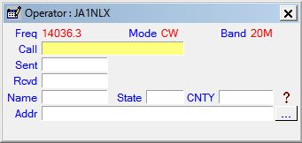

LBEW_19A

If User field 6 and 7 are not visible and this option is checked then you see like this.

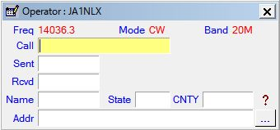

LBEW_19B

## 4.0 OTHER MENU ITEMS

* + <**Ctrl+F**> will open the Floating Callsign form;
  + <**Ctrl+K**> will open the CW Machine with focus in the Logbook Entry window.
  + <**Ctrl+X**> swaps the selected Scratchpad record with the Log entry.
  + <**Ctrl+Z**> will open the Scratchpad (if not already open) and toggle the Log entry to the Scratchpad.
  + **Change operator:** The Logger32 logbook is designed to be used by one or more operators. If you wish to change the operator who is using the log at the time, select this option and change the callsign.

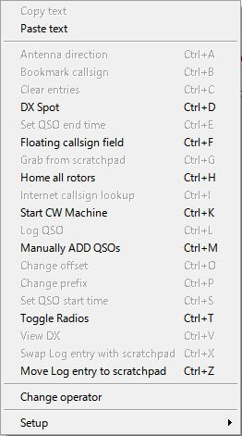

LBEW_20

### 4.1 Note For Control + Letter Functions